Program 6

Aim: Program to implement Multiple regression techniques using any standard dataset aavailable in the public domain and evaluate its performance

Source code: 1

import matplotlib.pyplot as plt  
import numpy as np  
from sklearn import datasets, linear_model, metrics  
  
boston= datasets.load_boston(return_X_y=False)  
  
x=boston.data  
y=boston.target  
  
from sklearn.model_selection import train_test_split  
x_train, x_test, y_train, y_test=train_test_split(x, y, test_size=0.4, random_state=0)  
  
reg= linear_model.LinearRegression()  
reg.fit(x_train, y_train)  
print('coefficient:',reg.coef_)  
print('varience score:{}'.format(reg.score(x_test, y_test)))  
  
y_pred = reg.predict(x_test)  
print(y_pred)  
plt.scatter(y_test, y_pred, c = 'green')  
plt.xlabel("Price: ")  
plt.ylabel("Predicted value")  
plt.show()

Output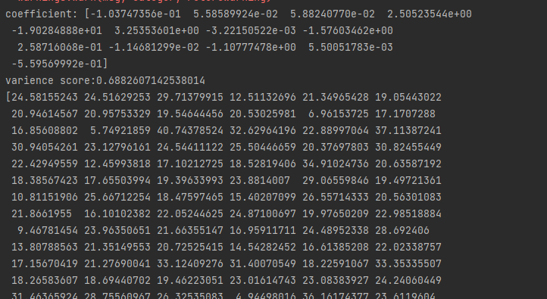

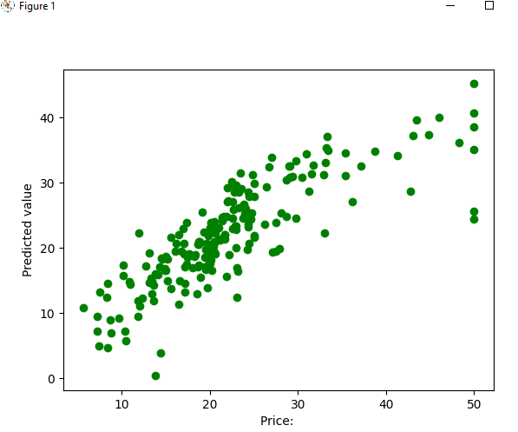

Source code2:

import pandas  
df = pandas.read_csv("cars.csv")  
x = df[['Weight', 'Volume']]  
y = df['CO2']  
from sklearn import linear_model  
regr = linear_model.LinearRegression()  
regr.fit(x,y)  
predictedCO2 = regr.predict([[1500, 1465]])  
print(predictedCO2)

Output:

